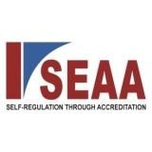 | 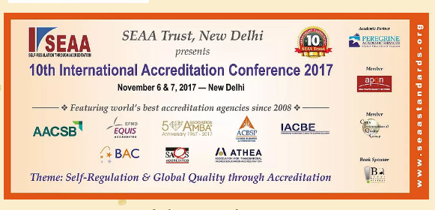
REGISTRATION FORM
10thAnnual International Accreditation Conference 2017
New Delhi November 6 & 7 2017
IIC Lodi Colony
Name :
Institution :
Address
Name , Phone number and Email of each delegate

Name | Mobile number | Email
1.

Details of the payment :Cheque Number : Bank :
Wiretransfer:Cheques are to be drawn in the name of SEAA Trust Wire transfer could be made to our SEAA Trust, Oriental Bank of India current account number 51511131001018. IFSC code is ORBC 0105151 branch is Vaishali Ghaziabad. International Delegates could pay US $ 200 and they could wire transfer using OBC SWIFT code ORBCINBBVIS or pay at the registration desk. FEE CHART:
Description | Amount | Details
Fee | 12,000 | Inclusive of GST
Early bird discount | 1000 per registration | Last date: 21stOctober 2016
SEAA Forum discount | Rs 1000 per registration | Only fully paid active members of the forum
Second registration | Rs 1000 off | The first registration is fully paid Rs 7 K and the second Rs 6,500
Discount for three or more registrations | Flat Rs 3000 on the total amount | Irrespective of number of registrations over 3 delegates this condition shall apply
We would be happy to offer one complimentary student registration for every delegate registered. For every additional student registration you may pay Rs 3000 per student. Registration formalities are same otherwise.

